91.404 Analysis of Algorithms

Final Exam

Name:

1. Recurrence (20 points) Related Outcomes: 1, 8
a. Find the tightest upper bound that you can on the closed-form solution for the following recurrence:

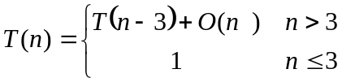

b.Find a tight upper and lower bound on the closed-form solution for the following recurrence:

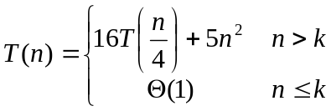

where k is a small integer. That is, find a function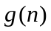 such that 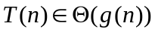.

2. QuickSort (10 points) Related Outcomes: 1, 7, 11

The following questions are related to quicksort and the partition algorithm is given.
  - (5 points) What is the best case cost of quicksort? When does it happen? Justify your answer.
  - (3 points) If we use quicksort to sort array A[9] = {8, 21, 11, 9, 17, 7, 20, 1, 15}. Show the content of array A after first time partition(), i.e., partition(A, 0, 8), is called. What value does this call return?
int partition(A, p, r)
{
x = A[r]; // use A[r] as the pivot
i = p-1;
for (j=p; j<=r-1; j++) {
if (A[j] <= x) {
i++;
exchange(A[i], A[j]);
}
}
exchange(A[i+1], A[r]);
return i+1;
}

3. Hash Tables (10 points) Related Outcomes: 12

For integer values of k, circle all the different values that can be obtained using the hash function:

h(k) = (k² + 4) mod 6

(a) 0 (b) 1 (c) 2 (d) 3

(e) 4 (f) 5 (g) 6 (h) 7

(i) 8 (j) 9 (k) 10 (l) 11

4. Pseudocode Analysis (10 points) Related Outcomes: 4, 5, 7, 12

In this problem a linked list L is searched from both ends for a key k. If k is in the list, a pointer to the node containing k should be returned. Otherwise, NIL should be returned. The list L is doubly-linked and has both head and tail pointers.

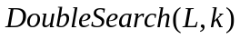
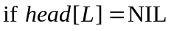
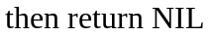
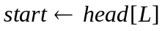
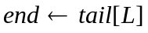
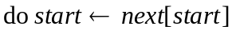
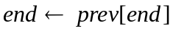
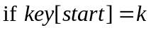
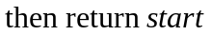
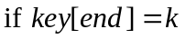
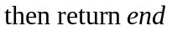
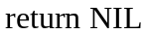

Is the pseudocode correct? If not, fix it. Justify your answer.

The remainder of this problem refers to the pseudocode fixed, if necessary, by you.
a. Show a best-case input scenario for DoubleSearch. How does this compare with a best-case input for LIST-SEARCH on p. 205 of our textbook?

b. Show a worst-case input for DoubleSearch. How does this compare with a worst-case input for LIST-SEARCH on p. 205 of our textbook?

5. (30 points) Design an Algorithm: Related Outcomes:1, 3, 4, 12

Given a Binary Search Tree T and a key value k, design an algorithm to efficiently locate and return all the records with key value equal to k. (Note that you will need to select an appropriate data structure for storing the records.)

The next 2 pages ask you to provide pseudocode, correctness justification and an upper bound on the worst-case asymptotic running time.
a) Pseudocode.

b) Justify the Correctness

c) Analysis: Provide as tight an upper bound on the worst-case asymptotic running time as you can.

Hint: You might want to express the running time as a function of the height h of the tree and the number of records found that have key values equal to k.

6. Graph Algorithms (20 points) Related Outcomes:13

We are running depth-first search on the graph below and assuming that the searches visit the neighbors of a node and the sources in numerical order (smaller first).

- Draw the breadth-first search tree starting from vertex 1. Give the distance from the source to each vertex computed by the algorithm, i.e. d[v] for v = 2, 3, …9.

1
2
6
3
4
7
5
8
9

- Draw the depth-first search tree (or forest). Give the discovery time and finishing time of each vertex.

1
2
6
3
4
7
5
8
9

- Does there exist a topological ordering for the graph? If yes, give an ordering. If no, justify.

We are running one of the two algorithms on the graph below. (ignore the directions on the edges for Prim's and Kruskal's).

- Show the order of nodes that are added to the partial solution by the Prim’s algorithm starting from node 1.
- What is the sequence of edges added by Kruskal's algorithm?

7
12
9
1
2
4
3
14
10
5

